**Different Types of Matrices**

**1. Row matrix or Row vector:**

A matrix A =(aij) 1X4 = (a11 a12 ........ a14 ) is called a row matrix or row vector of order N.

**Examples:**

1. A =

2. B =

3. C =

**2. Column Matrix or column vector:**

A matrix is said to be column matrix if it only consists value of a single column.

**Examples:**

1. A= 2. B= 3. C=

**3. Zero Matrix:**

If every element of an mn matrix is zero, then this matrix is called a zero matrix or null matrix. It is defined by 0 or |0|.

**Examples:**

1. A=

2. B=

**4. Square Matrix:**

A square matrix is a matrix with the same number of rows and columns.

If m=n, then A=(aij)m×n is called a square matrix of order n.

**Examples:**

**A**= is a square matrix of order 2.

**B** is a square matrix of order 3.

**C**= is a square matrix of order 4.

**5. Diagonal Matrix:**

A square matrix in which every element except the principal diagonal elements is zero is called a Diagonal Matrix.

A square matrix A=(aij)m×m is called a diagonal matrix if aij=0 ᵾ i ≠j.

**Examples:**

**A** is a diagonal matrix of order 3.

**B**= is a diagonal matrix of order 2.

**C**= is a diagonal matrix of order 4.

Identity matrix, null matrix, and scalar matrix are examples of a diagonal matrix.

**6. Scalar Matrix**

If the non-zero terms of a diagonal matrix are equal then it is called scalar matrix.

2 0 0

**Example.1** A = 0 2 0 is a scalar matrix.

0 0 2

**Example.2**

Scalar matrix of an order 1.

A = [1]

**Example.3**

Scalar matrix of an order 2.

A = 1 0

0 1

**Example.4**

Scalar matrix of an order 3.

5 0 0

A = 0 5 0

0 0 5

**Example.5**

Scalar matrix of an order 4.

7 0 0 0

A = 0 7 0 0

0 0 7 0

1. 0 0 7

**7.Unit / Identity Matrix**

If a11 = a22 = ---- = a44 = 1, then it is called unit / identity matrix.

**Example 1:**

1 0 0

I3 = 0 1 0

0 0 1

**Example.2**

I2 = 1 0

0 1

**Example.3**

1 0 0 0

I4 = 0 1 0 0

0 0 1 0

0 0 0 1

**Example** 4.

1 0 0 0

0 1 0 0

D= 0 0 1 0

0 0 0 1

**Example** 5.

1 0 0 0 0

0 1 0 0 0

E= 0 0 1 0 0

0 0 0 1 0

0 0 0 0 1

**8. Upper Triangular Matrix:**

A square matrix is called an upper triangular matrix if .

**Example** **1:**  U = is a 2*2 upper triangular matrix.

**Example** **2**: U = is a 2*2 upper triangular matrix.

**Example** **3:**  U = is a 3*3 upper triangular matrix.

**Example** **4:**  U = is a 3*3 upper triangular matrix.

**Example** **5:**  U = is a 4*4 upper triangular matrix.

**9.** **Lower Triangular Matrix**:

A square matrix [aij]m×n is called an upper triangular matrix  
 if aij=0, ∀ i>j  
  
  
**Example** **1:**    
  
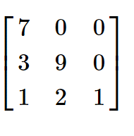  
  
**Example** **2:**

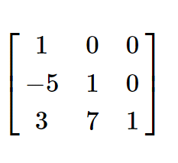

**Example** **3:**

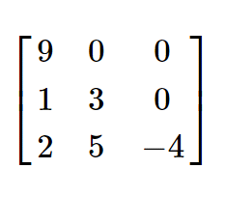

**Example** **4:**

A 3*3 Dimension lower-triangular matrix   
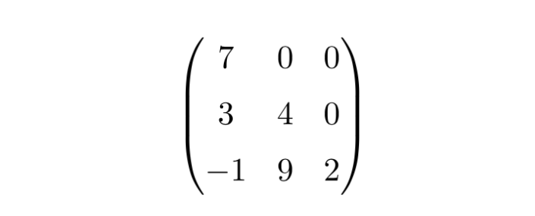  
**Example** **5:**

A 3*3 Dimension lower-triangular matrix   
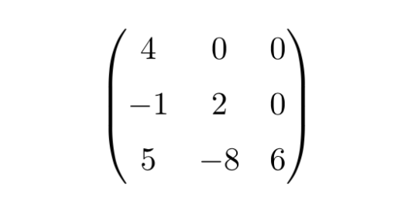

**10. Transpose Matrix**

Let A=(aij)mxn be a matrix , then the transpose of A written as AT or(At or A’) is the matrix of order nxm obtained by interchanging the rows and columns of A.

**Example 1- => AT**

**Example 2- => AT**

**Example 3- => AT**

**Example 4- => AT**

**Example 5- => AT**

**11. Periodic Matrix**

**Let A=(aij)mxn be a square matrix, if Ak+1=A where k**∈ℕ, then A is called periodic matrix and K is called period.

**Example 1**-

∴ A2

∴ A3

∴ A2+1=A that means A is a periodic matrix and period is 2.

**Example 2**- is not a periodic matrix because for no values of k there exists **Ak+1=A.**

**Example 3**-

∴ A2 =A

∴ A1+1=A that means A is a periodic matrix and period is 1.

**Example 4**-

∴ A2

∴ A1+1=A that means A is a periodic matrix and period is 1.

**Example 5-**

∴ A2

∴ A4

∴ A5

∴ A4+1=A that means A is a periodic matrix and period is 4.

**12. Idempotent Matrix:**

Idempotent matrix is a square matrix, which multiplied by itself, gives back the initial square matrix. A matrix When multiplied with itself, gives back the same matrix M,M2=M.

**Example** **1: if** A = [2 1 -2 -1]

**⸫** A2= [2 1 -2 -1 2 1 -2 -1] =[2 1 -2 -1] =A

**Example.2:**

**If** A= [-1 2 4 1 -2 -4 -1 2 4]

Then

A2= [-1 2 4 1 -2 -4 -1 2 4 -1 2 4 1 -2 -4 -1 2 4]

    =[1+2-4 -2-4+8 -4-8+16 -1-2+4 2+4-8 4+8-16 1+2-4 -2-4+8 -4-8+16 ]

     =[-1 2 4 1 -2 -4 -1 2 4]

Ie.A2=A

**Another examples of idempotent matrix:**

**Example** **3:**A=[2 -2 -4 -1 3 4 1 -2 -3]

**Example** **4**:A=[4 -1 12 -3]

**Example** **5:** A=[4 -2 6 -3]

**13. Nilpotent Matrix**

**Example 1:**

The matrix

A=

is nilpotent with index 2, since A2=0.

**Example 2:**

More generally, any n-dimensional triangular matrix with zeros along the main diagonal is nilpotent, with indexn. For example, the matrix

B

is nilpotent with

B2; B3; B4

The index of B is therefore 4.

**Example 3:**

Although the examples above have a large number of zero entries, a typical nilpotent matrix does not. For example,

C= C2=

although the matrix has no zero entries.

**Example 4:**

Additionally, any matrices of the form

Such as

**Example 5:**

Perhaps some of the most striking examples of nilpotent matrices are n*n square matrices of the form:

The first few of which are:

**14.Involutory Matrix:**

A square matrix be called involutory matrix if A2=1.

**Example 1:**

A=

**Example 2:**

B=

**Example 3:**

I=

**Example 4:**

S=

**Example 5:**

R-1=

**15. Symmetric Matrix**

A square matrix A=(aij)m×m is called a symmetric matrix if AT= A that is aij = aji

**Example 1-**

B=

BT =

Here, we can see that, BT = B. For example, b12b12 = b21b21 = 3, and b13b13 = b31b31 = 6. Thus, B is a symmetric matrix.

**Example 2-**

C=

∴ CT=

**Example 3-**

A=

∴ AT=

∴ A= AT so it is a symmetric matrix.

**Example 4:**

D=

**Example 5:**

E=

**16. Skew Symmetric Matrix**

A square matrix A=(aij)m×m is called a skew symmetric matrix if AT= -A that is aij = -aji

**Example 1-**

B=

∴ BT =

−B=−

−B=

Here, we can see that, BT = -B, b12 = -b21, and b11 = b22 = 0. Thus, B is a skew symmetric matrix.

**Example 2-**

C=

∴CT =

**Example 3-**

A=

**Example 4:**

D=

**Example 5:**

E=

**17.Conjugate Matrix:**

Let A=(aij)m*n be any matrix. In this case =()m*n is called conjugate matrix of A where is Conjugate element of aij.

**Example 1:**

A= =

**Example 2:**

A= ==

**Example 3:**

A= =

**Example 4:**

A=

**Example 5:**

A=, B=,A+B=

=

**18.Hermitian Matrix:**

A square matrix A=(aij)m*n be called Hermitian matrix if ()T=A that is =aij.

**Example 1:**

A=

**Example 2:**

B=

**Example 3:**

C=

**Example 4:**

D=

**Example 5:**

E=

**19. Orthogonal Matrix:**

A square matrix A = (aij)nxm is called orthogonal matrix if AAT = ATA = In = 1

**Example 1:**

AT =

A X AT = X = = I2

As the result gives the unit matrix, it is checked that A is an orthogonal matrix.

**Example 2:**

A = AT =

A X AT= X = = I3

The product results in the Identity matrix, therefore, A is an orthogonal matrix.

**Example 3:**

A = AT =

A X AT = X = = = I3

The product results in the Identity matrix, therefore, A is an orthogonal matrix.

**Example 4:**

A = AT =

A X AT = X = = = I2

The product results in the Identity matrix, therefore, A is an orthogonal matrix.

**Example 5:**

A = AT =

A X AT = X = = = I3

The product results in the Identity matrix, therefore, A is an orthogonal matrix.

**20. Unitary Matrix :**

A unitary matrix is a square matrix of complex numbers. A unitary matrix is a matrix, whose inverse is equal to its conjugate transpose.

**Example:**

**Row echelon form:**

A matrix is in row echelon form if:

1.Any row consisting entirely of zeros occur at the bottom of the matrix.

2.For two successive non-zero rows,the leading entry in the higher row is further left than the leading entry in the lower row.

3.All the entries in a column below a leading entry are zeroes.

**Example:**

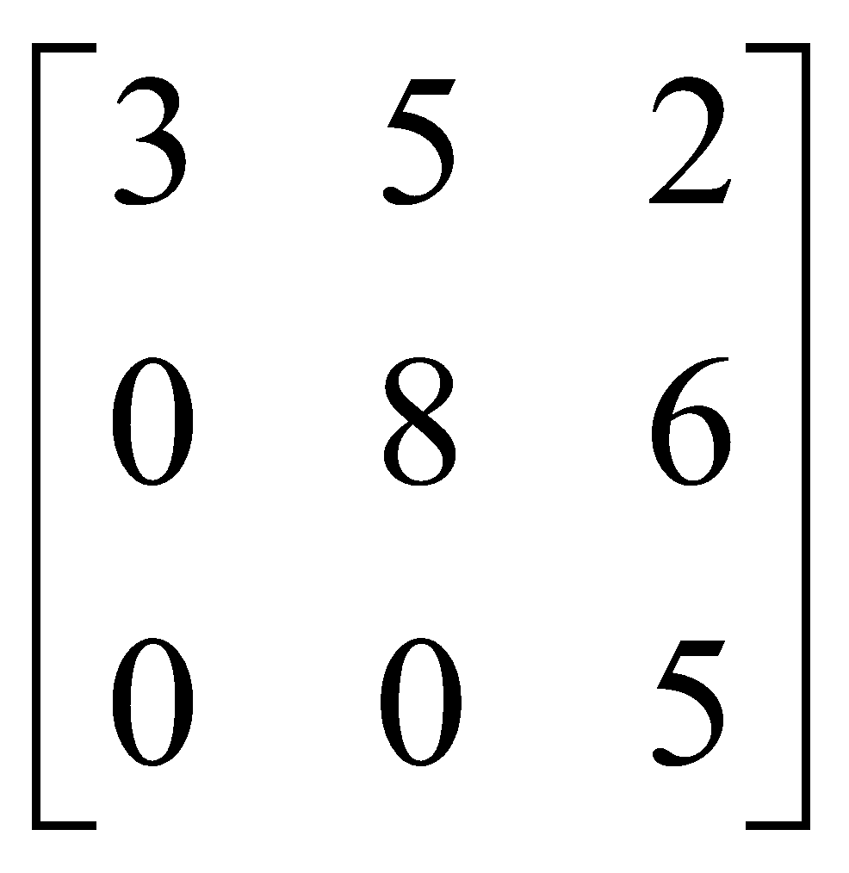

This is a 3 by 3 matrix which is in row echelon form. Here 3 ,8 and 5 are the leading elements.

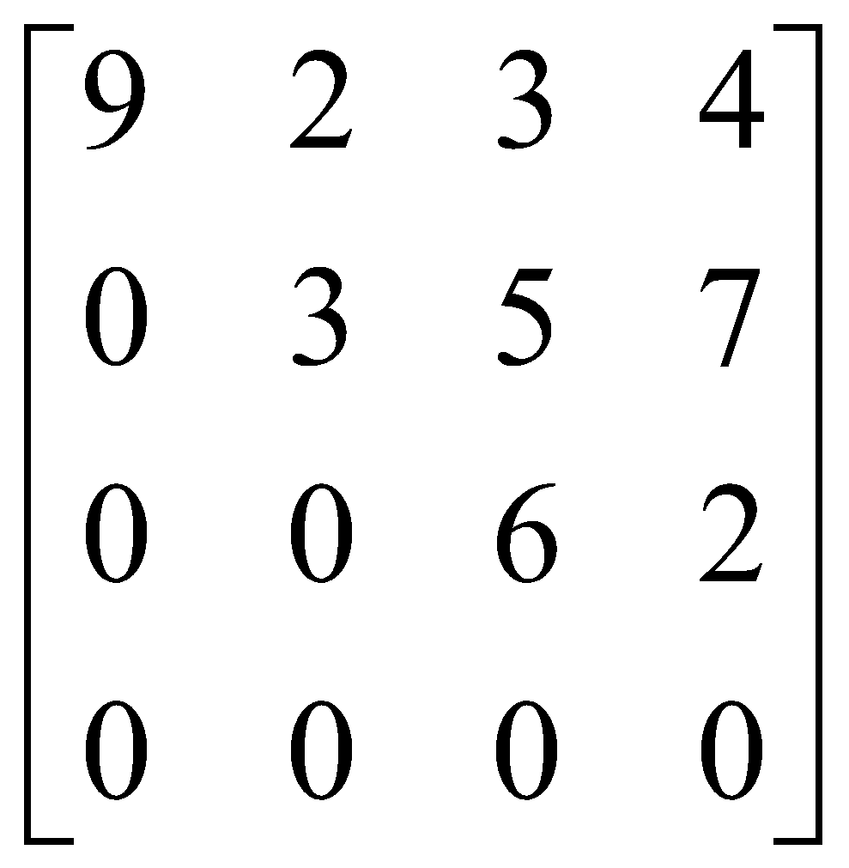

This is a 4 by 4 matrix which is in row echelon form.Here 9,3,6 are the leading elements.

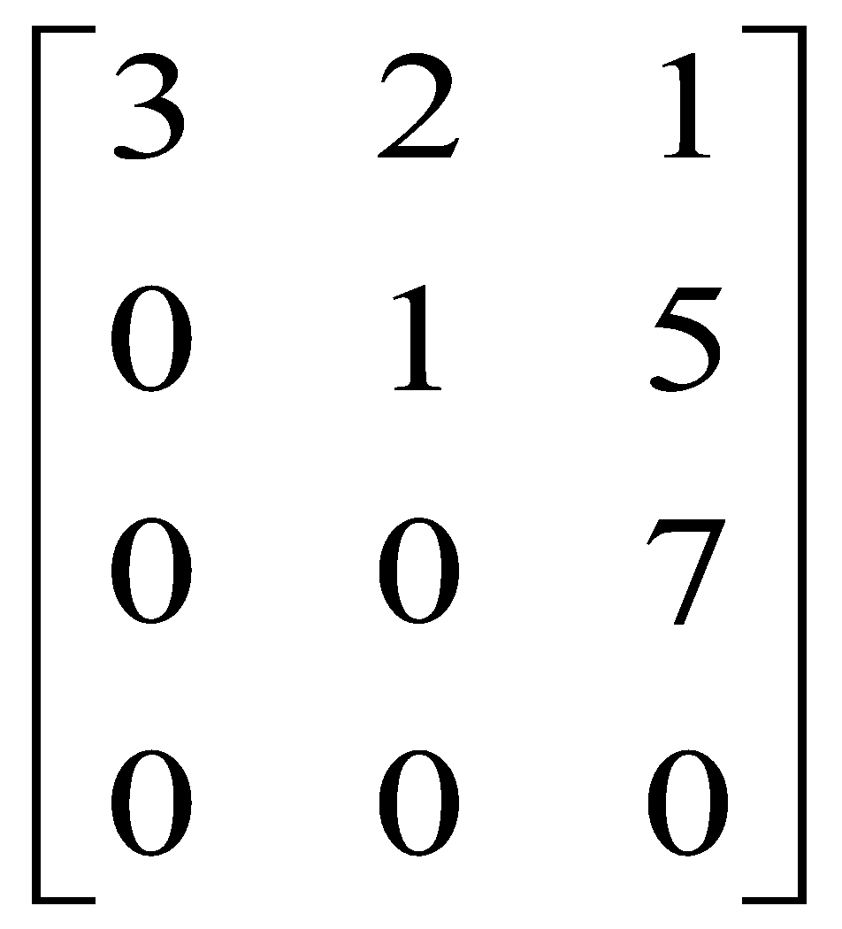 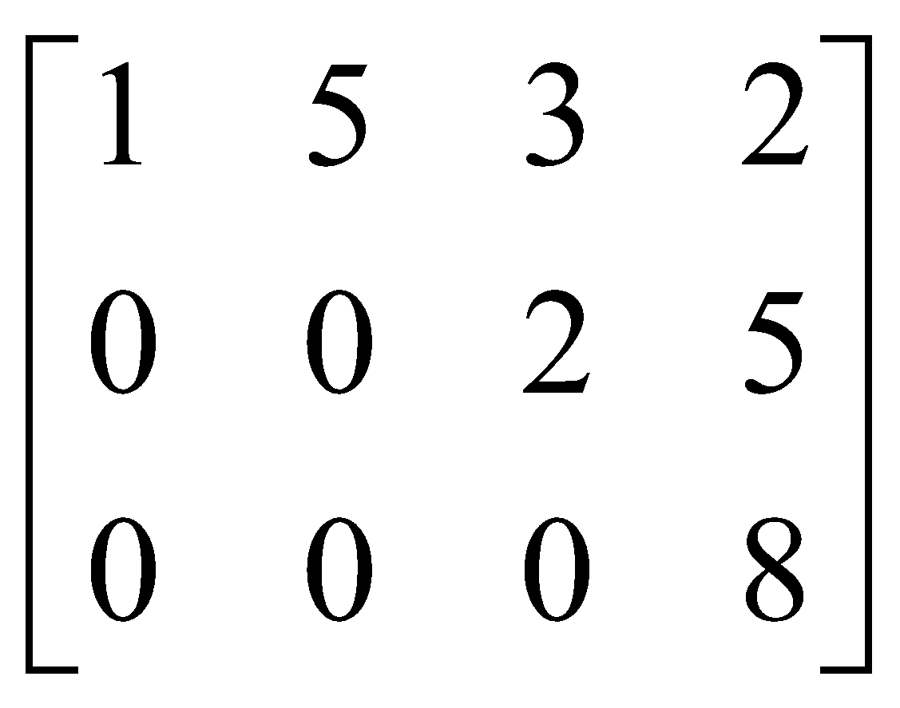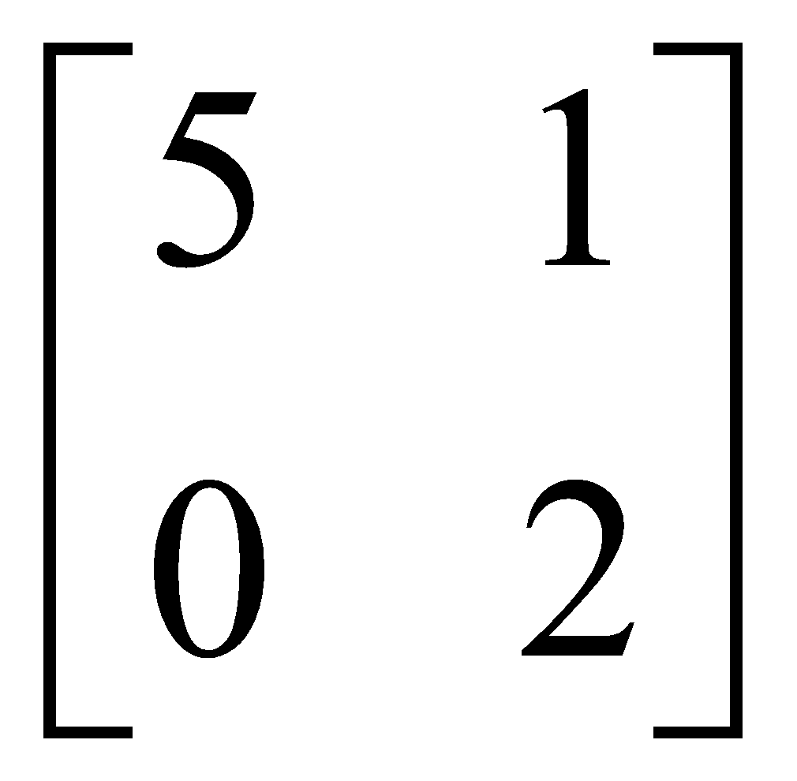

**Reduced row echelon form of a matrix:**

A matrix is a reduced row echelon form of a matrix if:

1. The matrix is in echelon form.
2. The leading entry of row is 1.
3. Each column which contains a leading entry of a row has all other entries zeros.

**Example :**

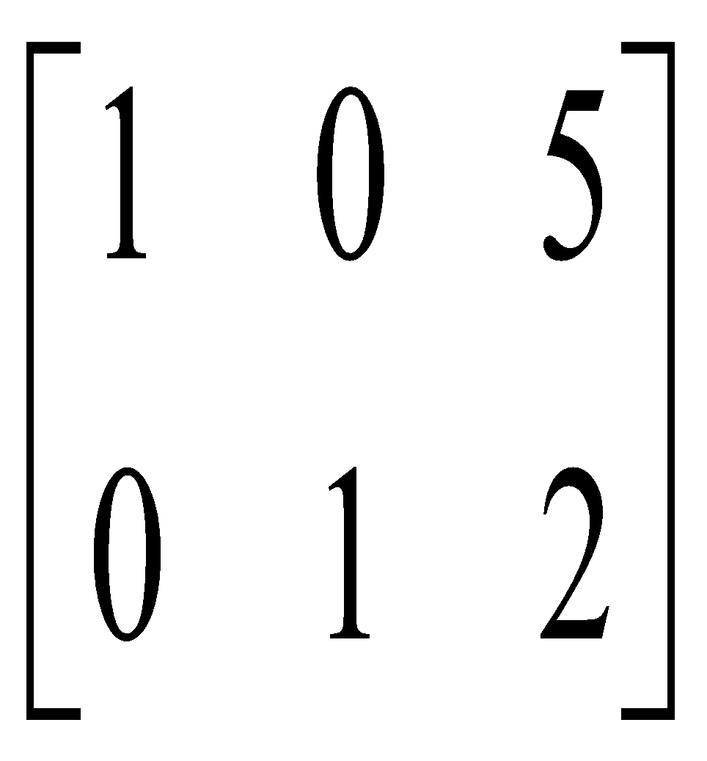 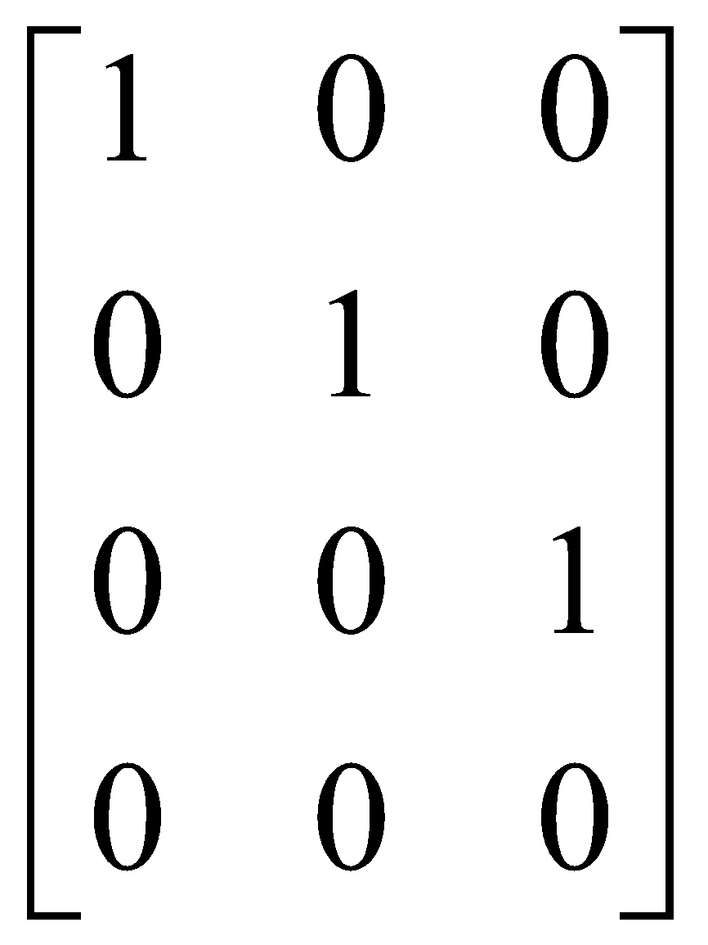 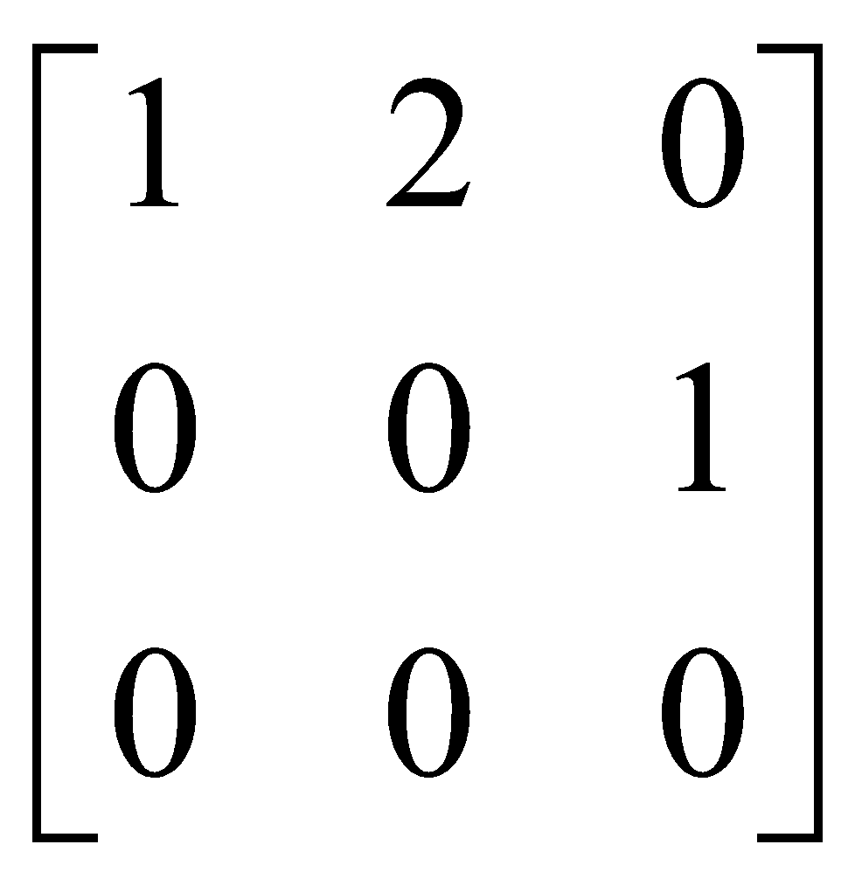 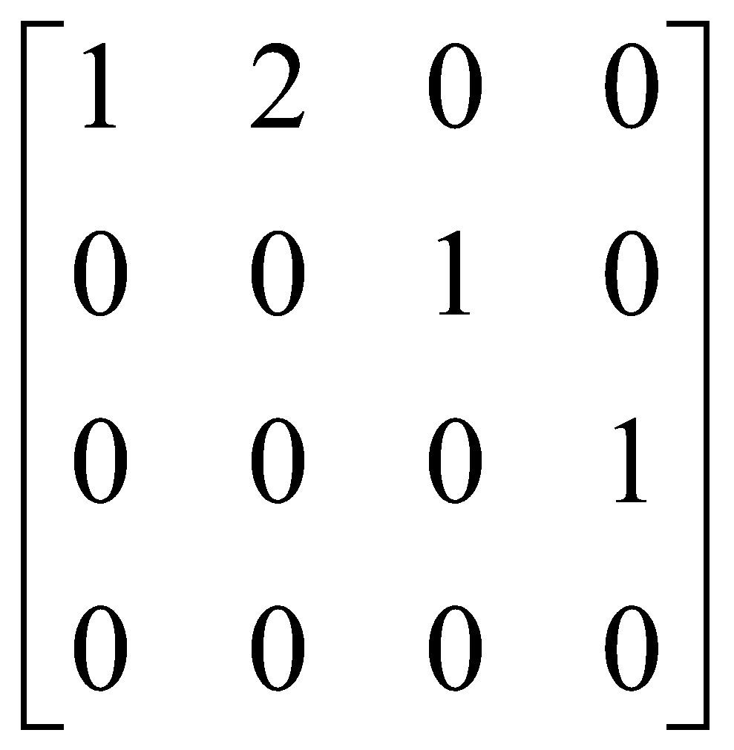

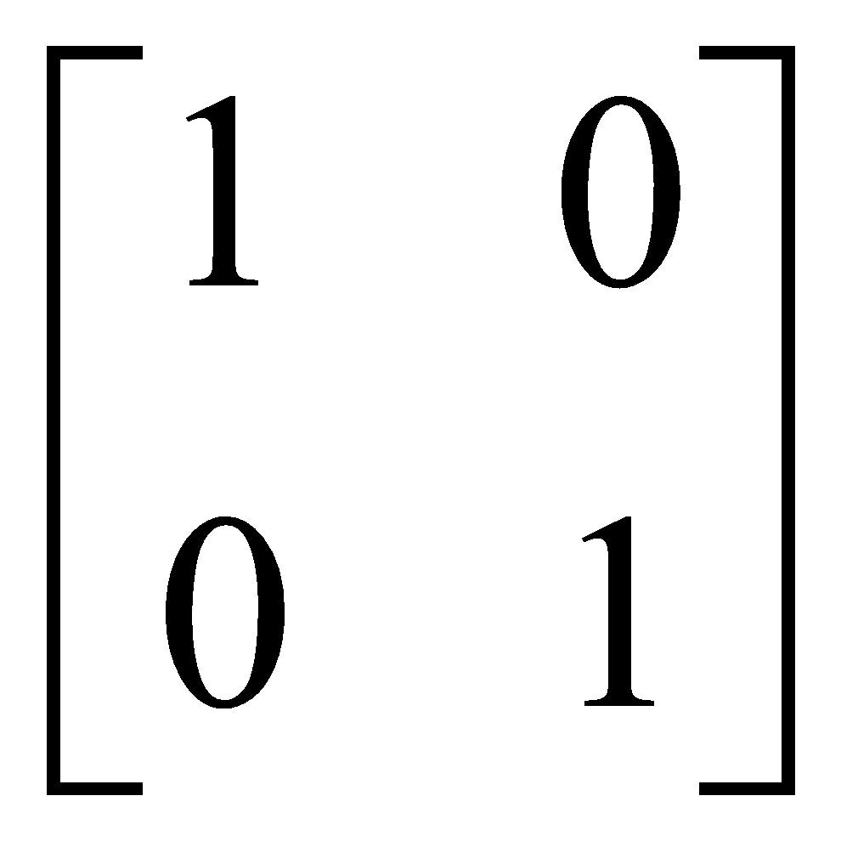

**Transformation of a matrix into row echelon form and reduced row echelon form:**

Let a matrix is: A=

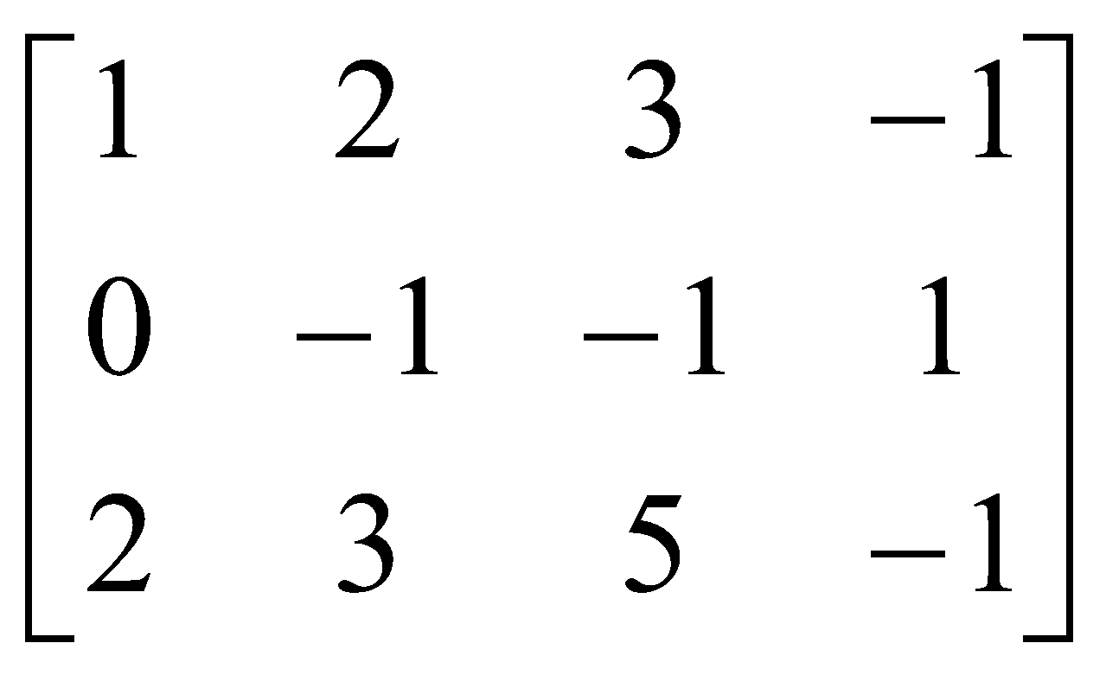

R3=R3-2*R1

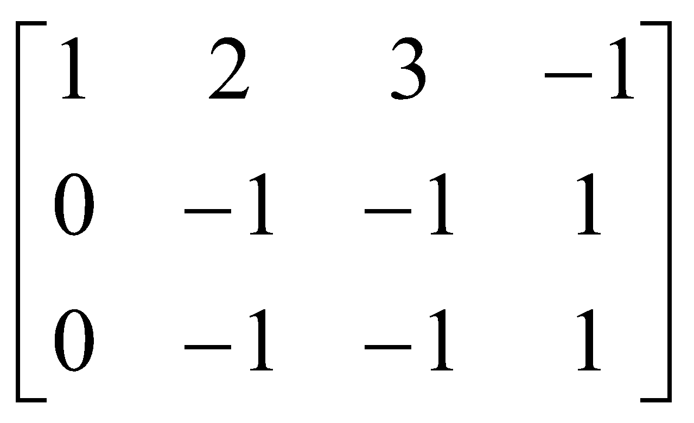

R2=R2*-1

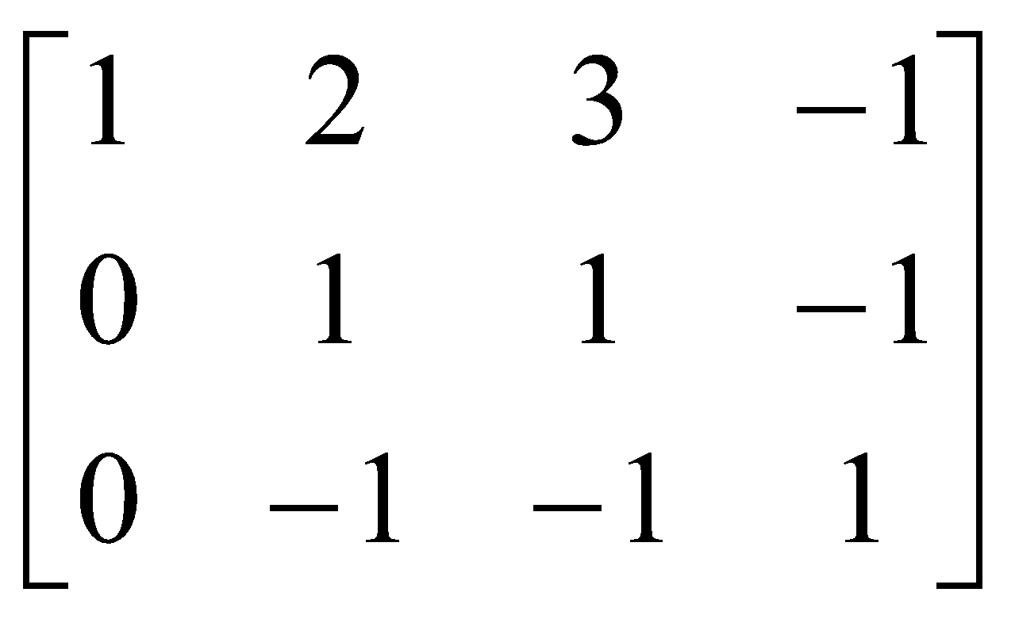

R3=R3-(-R2)

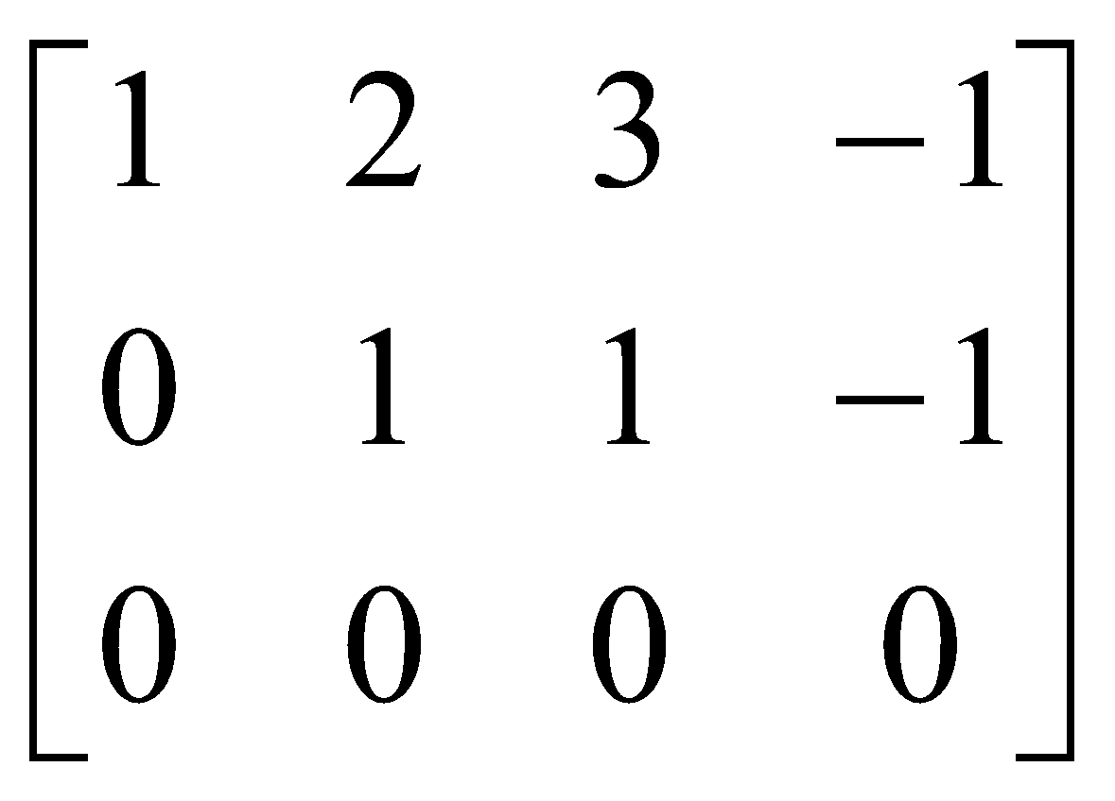

This is the echelon form of matrix A.

 R1=R1-2*R2;

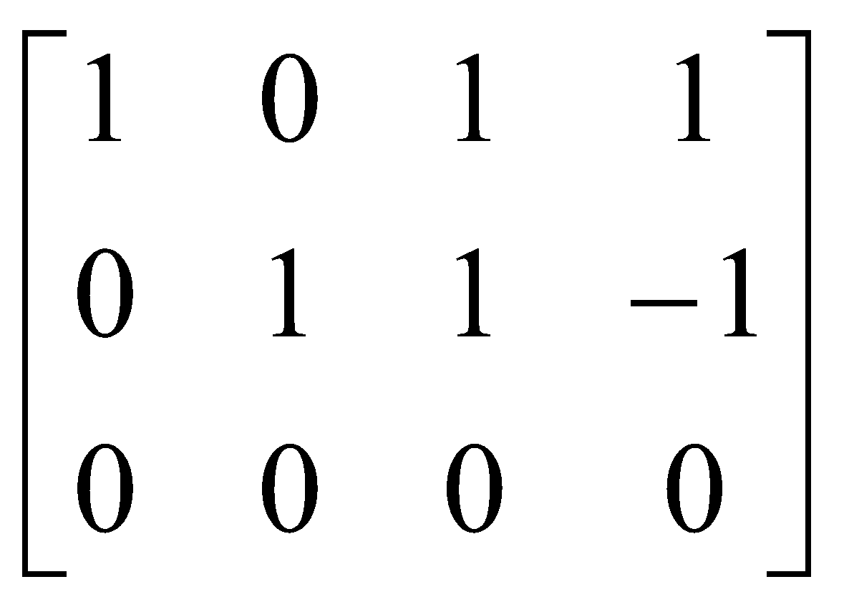

This is the reduced row echelon form of matrix A.